Abiotic Cyles

- The Carbon Cycle
- Free _______ is found in the atmosphere
- ___________ take in _____ in order to perform ______________. They release _______
- _________________ breathe in _____ and give off ______ as exhaled waste during _________________.
- ______________________ release carbon into the soil as they ________________
- __________________ (like oil) are ______________ from the carbon of ______________________
- Carbon in the soil is used by roots of plants. It is also _______________ into the ___________ and used by ___________ ____________ during photosynthesis.
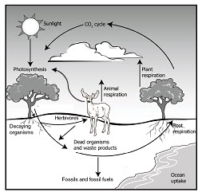
3
4
2
6
5
1
2

- Nitrogen Cycle

- Nitrogen is found in the atmosphere in the form of ________
- ______________________ – bacteria “fix” nitrogen so it can be used by plants
- Nitrates (NO₃⁻) are converted to _______________(NH₄+) by _______________ (biological chemicals that help reactions happen) in a process called ______________________.
- Ammonium is taken in by plants through a process called _________________ (when nitrogen fixing is not possible) to help them grow
- Dead organisms release ammonia back into the soil. This is called ____________________. Fungus (mushrooms) help with this process.
- Ammonia mixes with the oxygen in the soil and creates ________________ (NO₂-) and __________________(NO₃-). This is a problem because the negative charge doesn’t let the nitrogen mix with the soil.
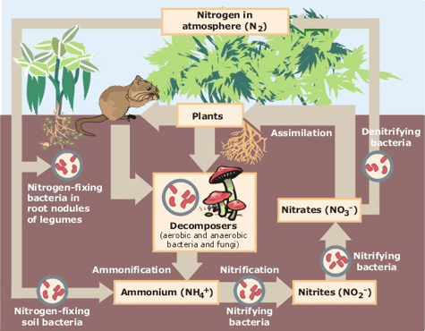
- Enzymes found in animal waste mix with the Nitrites and Nitrates to convert them back to N₂ which is released into the atmosphere. This is called _______________________
3
4
2
1
7
6
5

