The Carbon Cycle Experience
Teacher Page 1

TEKS: 12E
Describe the flow of matter through the carbon and nitrogen cycle and explain the consequences of disrupting these cycles

SWBAT (Students Will Be Able To):
- Draw or describe the carbon cycle they experienced labeling flow of carbon with arrows.
- Classify processes, organisms and environments in the cycle as sources or sinks.
- Answer questions about the effects of deforestation on the carbon cycle, fossil fuel emissions, and personal choices impacting emissions.

Identify
- Sources
- Sinks
- Fixers
- Respirators
- Combustion (fires, cars, factories)

Discuss
- Length of time in atmosphere (200 years)
- Length of time in ocean (100- 1000 years)
- Formation of fossil fuels
- Combustion
- Importance of plants

The Carbon Cycle Experience

Cut out the station cards and place around the room. Students will roll a dice to determine their next destination. The trip is recorded on the score card.

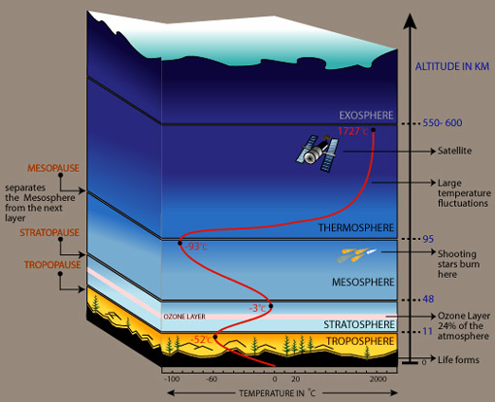
Station Stop #1 – Atmosphere
Station 1 - Atmosphere

1. You are one of many CO2 molecules in the atmosphere trapping heat. STAY
2. You are one of many CO2 molecules in the atmosphere trapping heat. STAY
3. You are dissolved into the Atlantic Ocean on a warm day. GO TO OCEAN
4. You are taken in by an oak tree and used in photosynthesis. GO TO PLANTS
5. You are taken in by a dandelion for photosynthesis. GO TO PLANTS
6. You are dissolved in the warm Gulf of Mexico. GO TO OCEAN
Station Stop #2– Plant

Station 2 - Plants
1. You are used in a campfire to roast s’mores. GO TO ATMOSPHERE
2. You are part of a rainforest burned for new fields. GO TO ATMOSPHERE
3. You are an oak tree burned up in a forest fire. GO TO ATMOSPHERE
4. You are a tasty berry eaten by a raccoon. GO TO ANIMALS
5. You are ferns that have died and decomposed, and are being converted with lots of pressure and time into fossil fuels. GO TO SOIL/ROCK
6. You are stored in the bark of a tree. STAY
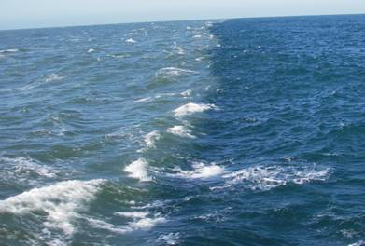
Station Stop #3– Ocean

Station 3 - Ocean
1. You are dissolved in seawater and could be here awhile. STAY
2. You are absorbed by phytoplankton and used to make sugars. STAY
3. You have just reacted with other chemicals in the water. STAY
4. You are in a bunch of plankton eaten by shrimp and fish in the Gulf of Mexico. GO TO ANIMALS
5. A dolphin just exhales as it took a breath by a tour boat and released you into the air. GO TO ATMOSPHERE
6. You are some plankton who just died and fell to the bottom of the ocean and eventually form fossil fuels. GO TO SOIL/ROCK
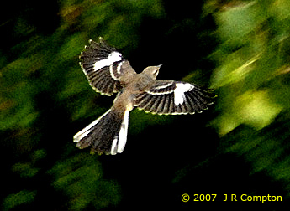

Station Stop #4– Animal

Station 4 - Animals
1. You are being released by bacteria decomposing a pile of dog poop. GO TO ATMOSPHERE
2. You were just breathed out by a bird flying south for the winter. GO TO ATMOSPHERE
3. A neighborhood dog just barked and released you into the atmosphere GO TO ATMOSPHERE
4. You are a fungus sitting on a tree stump releasing CO_{2.} GO TO ATMOSPHERE
5. You are a rotting porcupine carcass on the highway releasing CO₂. GO TO ATMOSPHERE
6. You are being breathed out by a bored science student. GO TO ATMOSPHERE

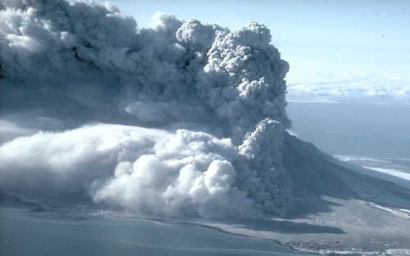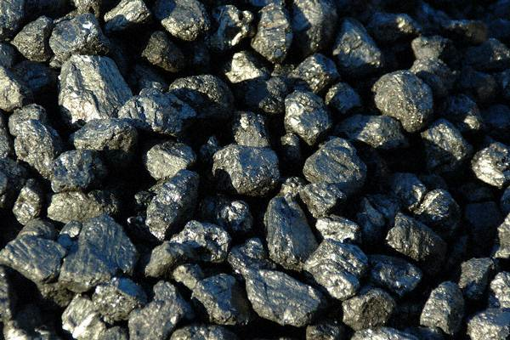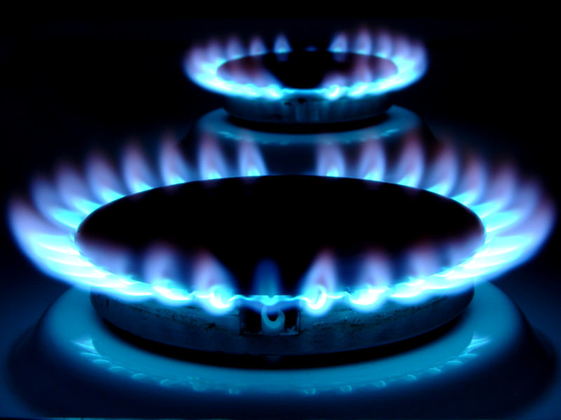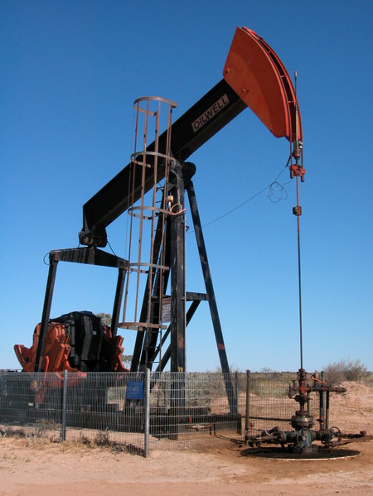
Station Stop #5 – Soil/Rock
Station 5 - Soil/Rock
1. You are changing into natural gas that is used to power our electrical plant. GO TO ATMOSPHERE
2. You are converted into petroleum that has been refined into gas for cars. GO TO ATMOSPHERE
3. You are converted into jet fuel for a politician’s private jet. GO TO ATMOSPHERE
4. You have been spewed out in a volcanic eruption. GO TO ATMOSPHERE
5. You are coal being burned in a coal power plant. GO TO ATMOSPHERE
6. You are still being changed into fossil fuels. STAY
Name ______________________________________________________ Class Period ______________________
YOU ARE A CARBON ATOM!!

 | Station Stop  (Example: Animals) | What Happened to You  (Example: Exhaled by a bear) | Destination/ Next Stop  (Example: Atmosphere)

After you have been through the carbon cycle once…
(You must visit each station at least once)
Step 2 : Answer the following questions.

1. What role do plants fill in the carbon cycle?

2. How could deforestation or the removal of plants affect the carbon cycle?

3. What are fossil fuels and how are they formed?

4. What could you do to reduce the amount of carbon dioxide in the atmosphere?

5. What are greenhouse gases?

Step 3: Highlight your journey through the carbon cycle. Use a highlighter to show where you moved.

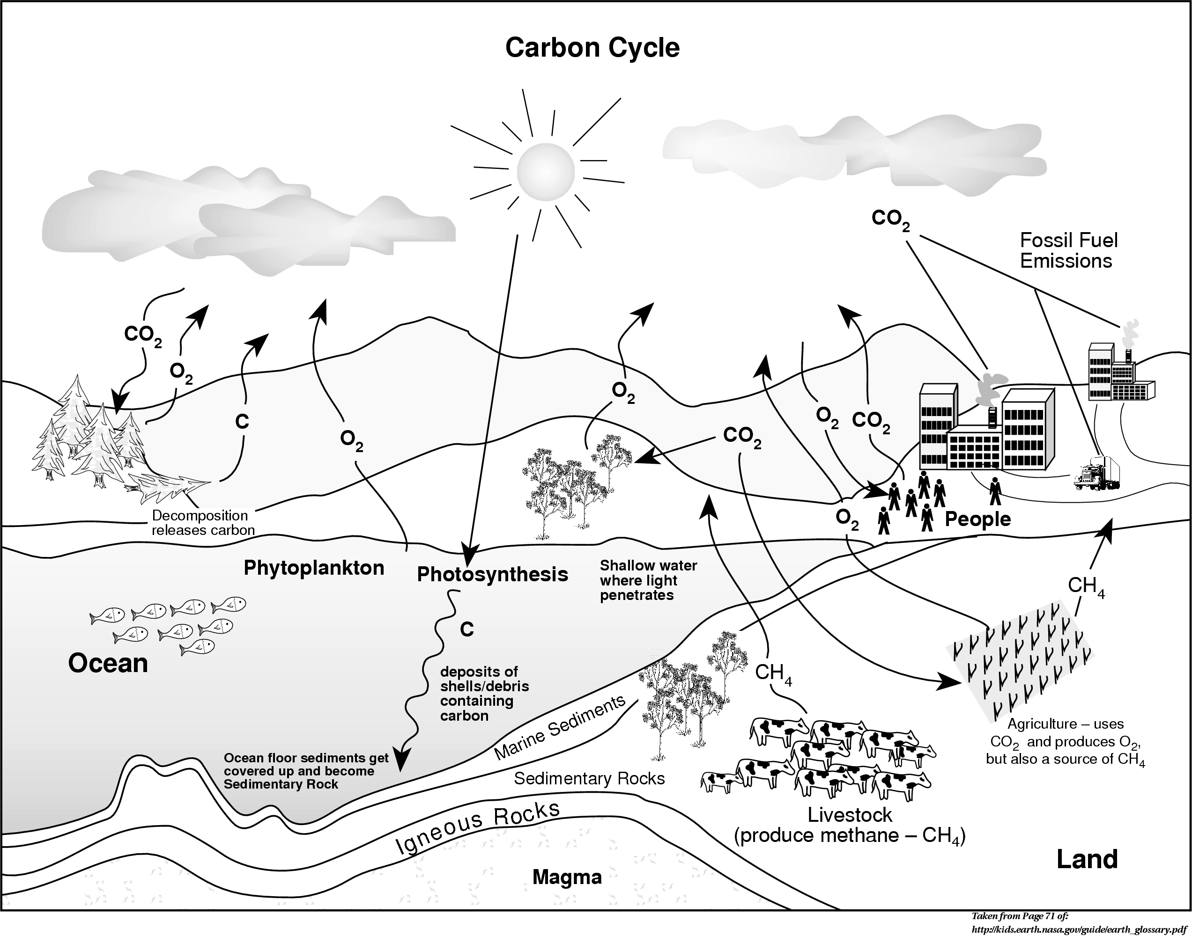

____________________ is a key ingredient of living tissues.

