Cell Structure & Function Test Review

1. Fill in the following Venn Diagram with information about prokaryotes and eukaryotes:

Prokaryote Eukaryote
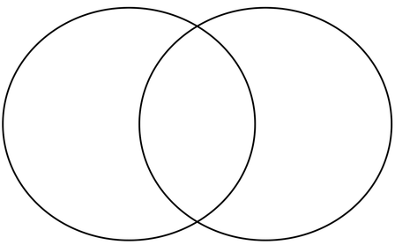
2. _______________________ are the basic unit of structure & function in living things
3. TRUE or FALSE: The genetic information found in all the nuclei of an organism’s cells are the same.
4. List the three characteristics that ALL cells (both eukaryotic and prokaryotic) have in common:

5. Identify and Draw the three types of Bacteria shapes

6. List the functions of bacteria. (4)

7. Which symbiotic relationship most accurately describes a virus with a host? ___________________________
8. What is the biggest difference between lytic and lysogenic cycle? Which one will display symptoms first?

9. What type of genetic material is in the capsid of a retrovirus? ____________________________
10. List an example of a fuel source for both plant and animal cells. Which biomolecule does it belong to?
ORGANELLE NAME | ORGANELLE FUNCTION | Plant, Animal, or Both
Nucleus
Cell membrane
Cell wall
Vacuole
Ribosome
Mitochondria
Chloroplast
Lysosome
Smooth Endoplasmic reticulum
Rough Endoplasmic reticulum
Golgi apparatus
Cytoplasm
Centriole

