CELL TRANSPORT: WARM UPS

WARM UP #1

|  |  |
| --- | --- |
| Which of the following is not a part of the Cell Theory?  A) All living things are made of cells  B) Cells are the basic unit of structure & function of living things.  C) Cork cells were the first to be named a “cell”.  D) New cells come from preexisting cells. | The cell above would be found in an   1. bacterium 2. moss 3. paramecium 4. yeast |
| **Cell:** | **Chloroplast:** |

WARM UP#2

|  |  |
| --- | --- |
| Movement of molecules from an area of low concentration to an area of high concentration is:  A. Active transport  B. Passive transport  C. Facilitated diffusion  D. Osmosis | Which of the following systems does not use osmosis and diffusion to complete its function?  A. Circulatory  B. Respiratory  C. Excretory  D. Skeletal |
| **Osmosis:** | **Diffusion:** |

WARM UP#3

|  |  |
| --- | --- |
| Movement of molecules from an area of low concentration to an area of high concentration is:  A. Active transport  B. Passive transport  C. Facilitated diffusion  D. Osmosis | Which cell process will move substances against a concentration gradient?  A. diffusion  B. facilitated diffusion  C. osmosis  D. active transport |
| **Osmosis:** | **Gradient:** |

WARM UP#4

|  |  |
| --- | --- |
| When a sea urchin egg is removed from the ocean and placed in freshwater, the egg swells and bursts. Which of these causes water to enter the egg?  A. Coagulation  B. Sodium pump  C. Active transport  D. Osmosis | The box contains some facts about kidneys and dialysis. Which of the following best explains why dialysis works? A. Dialysis reduces the size of proteins.  B. Proteins are dissolved by urine.  C. Dialysis filters proteins from solution.  D. Proteins transport membrane fragments. |
| **Define coagulation:** | **Define indication:** |

WARM UP#5

|  |  |
| --- | --- |
| Cells use passive and active transport to move materials across cell membranes in order to maintain a constant internal environment. What is the process of maintaining a constant internal environment called?  A diffusion  B evolution  C homeostasis  D respiration | If placed in a hypertonic solution, a plant cell will  A swell  B burst  C shrink in size  D remain constant in size |
| **Define Active Transport:** | **Define Constant:** |

Warm Up#6

|  |  |
| --- | --- |
| The cell membrane of the red blood cell will allow water, oxygen, carbon dioxide, and glucose to pass through. Because other substances are blocked from entering, this membrane is called  A perforated  B semi-permeable  C non-conductive  D permeable | The picture shows a cell model and the solutions associated with it. In this situation the cell model will—  A. gain mass  B. shrink  C. increase in solute content  D. start to vibrate |
| **Define perforated:** | **Define permeable:** |

Warm Up#7

|  |
| --- |
| Explain the difference between osmosis and diffusion. |

BONUS WARM UP (10 Extra Points)

Across

3. movement of water

6. solution that causes a cell to swell

7. transport that does not require energy

Down

1. molecules move from high to low concentration

2. solution in which the concentrations are the same

4. solution that causes a cell to shrink

5. transport that requires ATP

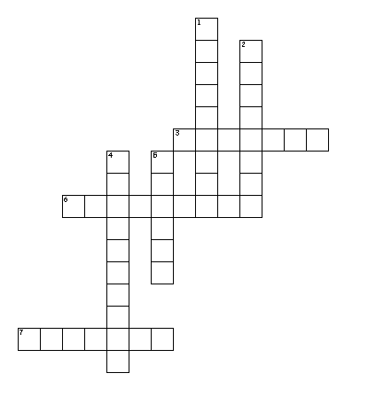

**Demo Dialysis Tubing**

|  |  |
| --- | --- |
| **Draw the original set up.** | **Draw the final appearance.** |
| **What conclusions can be drawn?** | |