Cellular Transportation
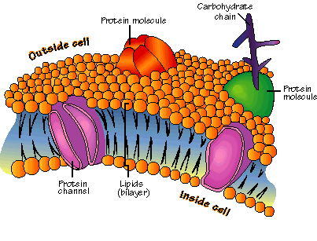
Cell Membrane:
- Cell membranes are semi permeable. This means that the cell membrane will only allow certain molecules through it.

There are different ways that substances travel across the cell membrane.

- Passive Transport: NO ENERGY NEEDED!
Diffusion: Compounds move from high concentration to low concentration. Substances will continue to move until equilibrium is reached.
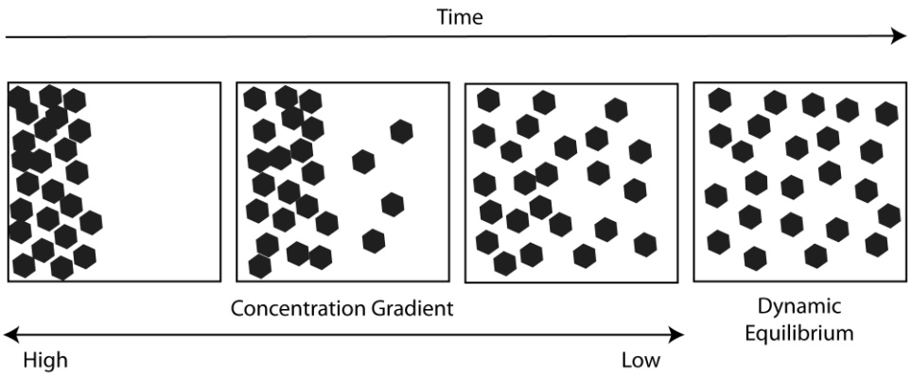

Osmosis: the diffusion of water

- Active Transport: ENERGY REQUIRED!
Endocytosis: Large compounds are brought into the cell
Exocytosis :Large compounds are sent out of the cell
Phagocytosis: Cytoplasm surrounds a particle and packages it within a food vacuole
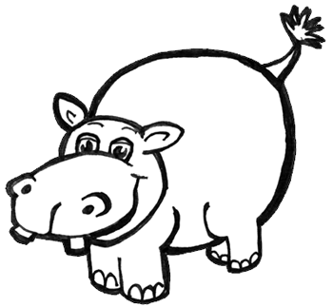
The Effect of Osmosis of Cells

Osmosis is the diffusion of water.

HYPOTONIC__: Water moves into the cell and causes the cell to SWELL.

HYPERTONIC: Water moves out of the cell and causes the cell to SHRINK.

ISOTONIC: Concentrations are equal or the same. This causes the cell to remain its normal shape. The amount of water is balanced inside and outside the cell.

