Circulatory System Notes
**The circulatory system carries _______________, _________________, and ___________________________ to and from different places in the body.
****The circulatory system consists of the _________________, ________________, and the ______________.
The circulatory system works like a highway in a city. Your blood delivers nutrients and oxygen to the tissues in your body just like the highways are used to deliver goods in a city.
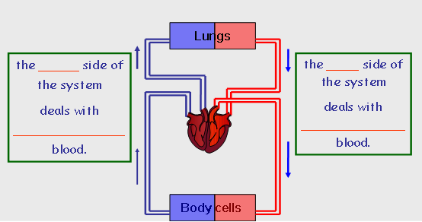
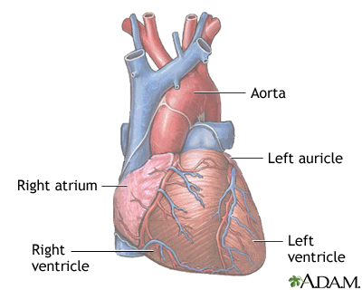
The heart has ____ chambers.
___ atria
___ ventricles
________ carry blood from the body.
This blood DOES NOT contain oxygen.

________carry blood away from the
heart. This blood DOES contain oxygen.

How does the Heart work?
STEP ONE
The heart beat begins as the heart muscles ________and blood ________ into the atria.
STEP TWO
The atria then _______________ and the valves ___________ to allow blood into the __________________.
STEP THREE
The valves _________________ to stop blood from flowing backwards.
The ventricles ___________________ forcing the blood to leave the heart.
At the same time, the atria are _____________ and once again filling with ______________.
***The cycle then _________________ itself***
Blood from the heart gets around the body through ______________________.
There are 3 types of blood vessels:
- ___________________ carry blood ___________from the heart
- ___________________ carry blood _________ the heart
- ___________________ link _____________ and __________

SUMMARY
Arteries take blood ______ from the heart. The walls of an artery are made up of thick _________ walls and elastic fibres. Veins carry blood ________ the heart and also have valves. The _________ link arteries and veins, and have a one cell thick wall. Blood is made up of four main things ______, the liquid part of the blood; Red Blood Cells to carry ______; White Blood cells to protect the body from disease and _________ to help blood clot.

