Ecological Pyramids
An ecological pyramid is a diagram that shows the relative amount of _________________________________ available at each trophic level of a food chain.

- _____________________________ – shows the amount of energy available at each trophic level.

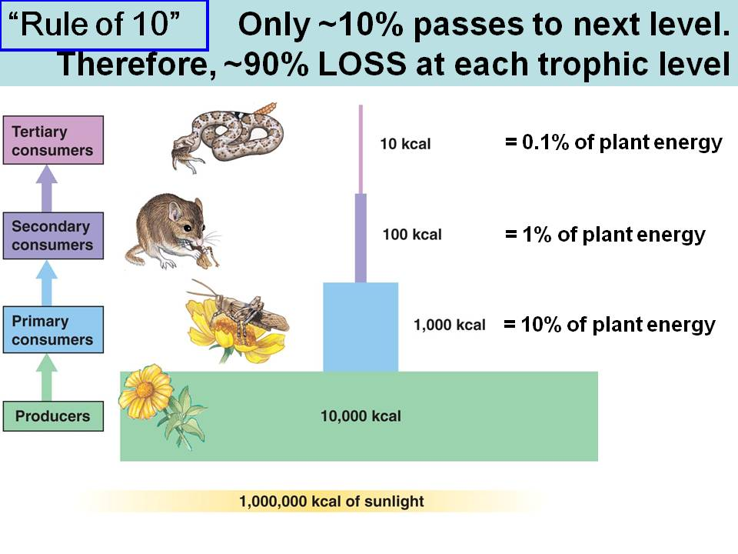

Only ________ of the energy available within one trophic level is transferred to the next level.

Example –if the insects provide __________ of energy to the rodents, the rodents only get ______ other 900 kcal was used by the insects for body ___________________________ and some was __________________________.
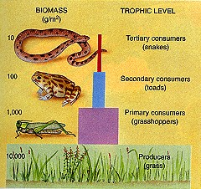

- ___________________________ - represents the amount of living matter at each trophic level.

- measured in _____ or ______

  - ___________________ usually account for the most biomass

