Name: __________________________ Period:_______________ Date:__________________
Ecology Test Review
- List the levels of organization in ecology from smallest to largest

Symbiotic Relationships:
- A mosquito sucking blood from a human is what kind of symbiotic relationship? ___________________________

- ________________________is a relationship between members of the same or different species in which individuals are adversely affected by those having the same living requirements, such as food or space.

- ________________________A form of symbiotic relationship between two organisms of unlike species in which one of them acts as predator that captures and feeds on the other organism that serves as the prey.

- _________________________is the way two organisms of different species exist in a relationship in which each individual benefits from the activity of other.

- _________________________, in biology, a relationship between individuals of two species in which one species obtains food or other benefits from the other without either harming or benefiting the latter

- _____ % of energy is passed from one trophic level to the next while _____% of energy is lost as _________________________________.

- Draw and label a pyramid with four trophic levels

- What is the original source of the energy in the pyramid above? __________________

- Which level has the largest biomass? ___________________________________

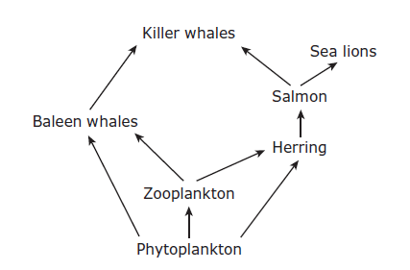

- In the food web above:
- What is missing from the food web above?

- Name the producer(s)

- Name the primary consumers

- Name the secondary consumers

- Name the quaternary consumers

- The arrow points at whom? (The one eating or the one being eaten)

- Define Succession –

- Primary succession starts with _______________________________
List examples of Primary Succession:

- Secondary succession starts with _____________________________
List examples of Secondary Succession:

- What are the two pioneer species for primary succession?
a.
b.

- Circle the climax community.
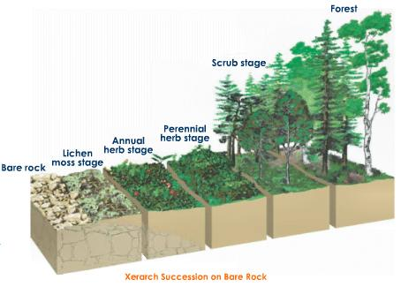
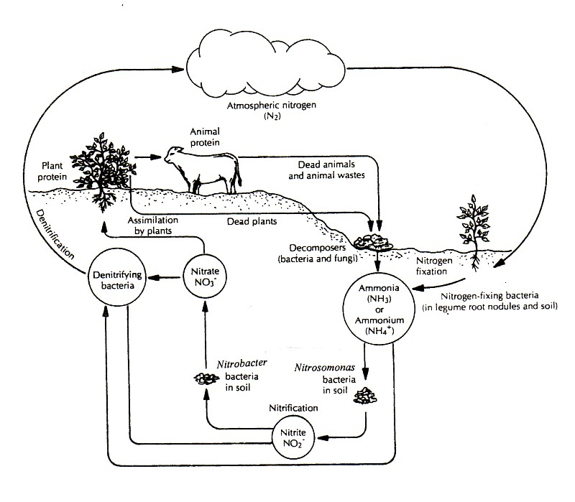

- What abiotic factor is being recycled in the diagram to the left?
____________________________

- Explain how carbon moves from autotrophs -> consumers -> decomposers. What role do fossil fuels play?

