Nervous System Power Point Notes
- List the 3 basic tasks of the nervous system.
1.
2.
3.

- The nervous system controls ______________________________________________________.

- The central nervous system is made up of the _______________________________________ and

the _____________________________________________.

- The main function of the spinal cord is to ___________________________________________.

- What protects your spinal cord? ________________________________________.

- The brain controls____________________________________.

- The ___________________________ is the largest part of the brain controlling

_________________ and ______________________ and ___________________ and

_________________________.

- The cerebellum controls _________________________and ____________________.

- The brain stem controls_______________, ______________________, and __________________.

- The 2 parts of the Outer(peripheral) Nervous System are ________________________ and

____________________.

- Messages are carried throughout the body by __________________________.

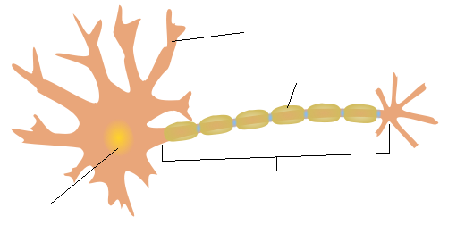

Label the neuron above with: nucleus, myelin sheath, dendrite, & axon

- Autonomic nervous system controls activities that you don’t have to ____________about, like

_______________________, _______________________, and ________________________

- Sense organs carry messages about the________________________ to the

_______________________________.

- List the sense organs and their function.

1.

2.

3.

4.

5

