**Nutrient Limitations**

* _______________________ – the rate in which organic matter (carbon, oxygen, nitrogen, phosphorus) is created to producers.
* When a nutrient is in short supply, it _______ how much the organisms can grow and reproduce. This is called a ______________ _________________.
* When an aquatic ecosystem receives a large supply of a limiting nutrient, such as runoff water from heavily fertilized fields, an ____________________is the result.

Algal bloom- _ __________________________________.

* Results of an Algal Bloom:
* _____________________________________ the thick layer of algae causing plants on the bottom die
* If the plants on the bottom die, the fish and animals that eat them could _________________________.
* _____________________________________________

**Carrying Capacity**

* the ____________________________ that can be ___________ by the available resources
  + __________________ may include food, water, shelter, space, oxygen, etc.
* When the carrying capacity of an area is exceeded, populations will begin to ___________________ because there aren’t enough resources to support them.

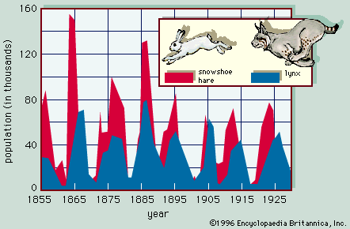**Limiting factors** keep populations _______________________.

* If one species is disturbed it _______________________ on the populations of other species.

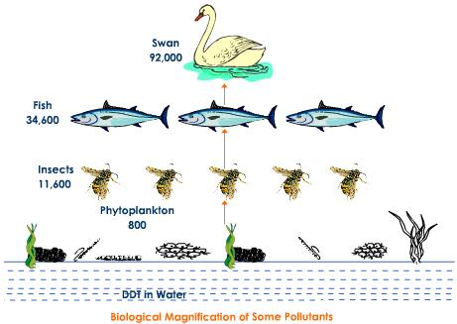

**Biomagnification**, is the _______________ in __________________of a substance that occurs in a food chain

* ________ - a harmful pesticide often found in food chains

**Ecological Succession**

**____________________** is a series of changes in a community in which new populations of organisms gradually replaces existing populations.

* There are ______________ of succession:

1. **____________________________** – starts from bare rock
   * + ___________________ - the first organisms to colonize a new site.

* ________________________ are pioneer organisms.

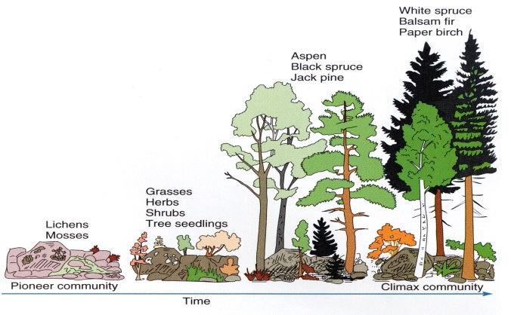

1. **______________________** – Takes place on _____________________
   * Populations grow again after being wiped out by a _________________________________

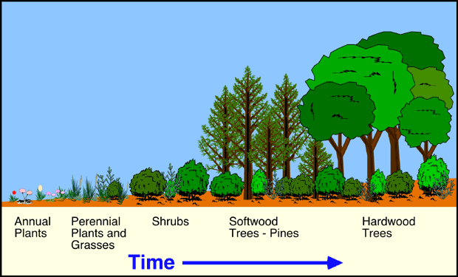

Climax Community/ Mature Community – the most stable community during succession.

- composed of large, sturdy **___________________________**.