PLANT WARM UPS
CHLOROPLAST
FRUIT
PHLOEM
SEED
STROMA
XYLEM
CUTICLE
LEAF
PHOTOSYNTHESIS
STEM
THYLAKOID
FLOWER
MESOPHYLL
ROOT
STOMATA
TRANSPIRATION

Warm Up #1
R | O | O | T | G | D | Q | Q | K | F | Y | M | Z | L | E | A | F | A
T | H | Y | L | A | K | O | I | D | F | R | U | I | T | L | S | C | T
A | C | S | I | S | E | H | T | N | Y | S | O | T | O | H | P | U | A
C | H | L | O | R | O | P | L | A | S | T | S | E | E | D | X | T | M
M | E | S | O | P | H | Y | L | L | M | E | O | L | H | P | Y | I | O
S | T | R | O | M | A | G | H | R | E | W | O | L | F | N | L | C | T
M | E | T | S | Y | T | X | S | M | A | U | E | B | R | S | E | L | S
T | R | A | N | S | P | I | R | A | T | I | O | N | X | S | M | E | P
Warm Up #2
The Xylem is in the stem part of the plant that transports ______, while its neighbor the phloem transports _______.  - Nutrients / Water  - Chloroplats / Guard Cells  - Pollen / Water  - Water / Nutrients | This tiny whole or pore that is located on the bottom of leaves, help regulate gas exchange and water loss.  - Cuticle  - Epidermis  - Stomata  - Phloem
Define Guard Cells:  Define Chloroplast: | Define Phloem:
Warm Up#3
What is the most likely seed dispersal mechanism for a seed with wing-like structures?  - Wind  - Water  - Eaten by animals  - Catch in animal Fur | How does the function of plant leaves benefit the whole organism?  - Support the plant  - Produce flowers  - Trap sunlight for photosynthesis  - Take in water
Define dispersal: | Define: photosynthesis
Warm Up #4
Species of the genus Toxicodendron, which includes poison ivy and poison oak, produce a gummy oil that causes a severe itchy rash in some animals. This substance is part of the Toxicodendron species’ –  - Defense mechanism  - Nutritional processes  - Support system  - Clinging ability | In most plants, what structure is solely used for reproduction?  - Flowers  - Leaves  - Roots  J. Stem
Define severe: | Define solely:
Warm Up #5
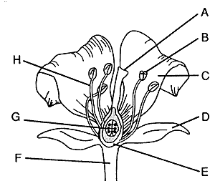
Label the parts of the plant and list the main job associated with each part.

