Respiratory System
Label the respiratory system below: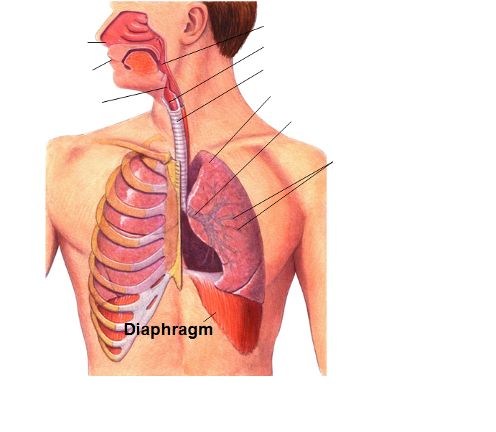
What is respiration?
In biology, respiration means different things.
________________________ is the release of energy from the breakdown of food in the presence of oxygen in occurs in which organelle?) _____________________________
At the organism level, respiration is the process of __________ ________________—the release of carbon dioxide and the uptake of oxygen that occurs between RBCs and alveoli
_____________________________ is the actual mechanical intake of air.

Breathing
Lungs are sealed in _________________ membranes inside the chest cavity.
At the bottom of the cavity is a large, flat muscle known as the __________________________.
Inhalation
During inhalation, the diaphragm ___________________ and the rib cage rise up. This expands the volume of the chest cavity.
The chest cavity is sealed, so this creates a partial _________________ inside the cavity.
Atmospheric pressure fills the lungs as air _____________ __________the breathing passages.
Exhalation
Often exhaling is a event.
When the rib cage lowers and the diaphragm , pressure in the chest cavity is greater than atmospheric pressure.
Air is of the lungs.
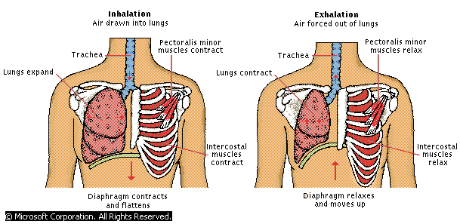
How is breathing controlled?
Breathing is controlled by the _________________ _______________________.
The medulla oblongata monitors _________________ __________________in the blood.
As carbon dioxide increases, nerve impulses make the diaphragm __________________, bringing air into the lungs.
The higher the carbon dioxide level, the stronger the impulses.
What happens after you inhale?
are clusters of tiny sacs at the ends of air passages.
A network of surrounds each alveolus.
___________ ______________________ takes place in the alveoli.
_________________ diffuses the blood.
in the blood diffuses the blood to the alveolus.
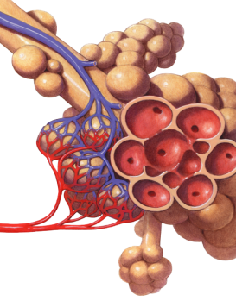 Label the parts of the alveoli 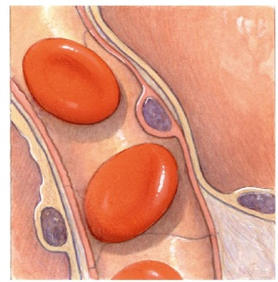 In the picture, label the flow of gasses

