Name: __________________________ Period: _______________ Date:__________________
Classification Review
VOCABULARY YOU MUST KNOW!
*Classification, Taxonomy, prokaryote, eukaryote, unicellular, multicellular, autotroph, heterotroph, motile/non-motile, dichotomous key, binomial nomenclature, manipulated variable, response variable, hypothesis*

- Fill in the Kingdom Characteristics
 | Archaebacteria | Eubacteria | Protista | Fungi | Plantae | Animalia
Cell Type
Organization
Nutrition
Locomotion
(Motile/
Non-Motile)

- List the 8 Characteristics of living organisms.

- Define Binomial Nomenclature. What language do we use?

How many rules apply? ________ List the rules below.

- How many levels of Classification are in Carl Von Linne’s (Carl Linnaeus) taxonomy? _____
- List the levels from broadest to most specific.

- Which levels do we use in Binomial Nomenclature.

- Why is it important/beneficial to have an established taxonomy system in place?

- Define and list the Domains.

- Explain the difference between prokaryotes and eukaryotes. List the kingdoms for each cell type.

- Define Autotroph.

- Define Heterotroph

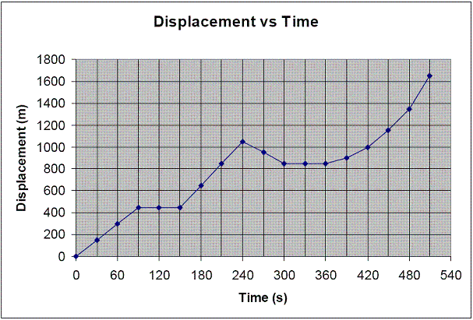
- Look at the graph above, Identify the manipulated and response variables.

