Warm Ups: Photosynthesis and Cellular Respiration
Warm Up #1
Photosynthesis is the process in which  a. plants capture sunlight and produce carbohydrates.  b. animals eat plants.  c. animals eat other animals that have eaten plants. | Which of the following is a product of photosynthesis in plants?  - Carbon dioxide  - Water  - Glucose  - Light
Define photosynthesis: | Define product:

Warm Up #2
Write the equation for photosynthesis. Label the products and reactants.

Warm Up #3
Plants gather the sun’s energy with light-absorbing pigments called  A. chlorophyll.  B. thylakoids.  C. chloroplasts.  D. glucose. | If all the water is completely removed from a plant’s environment, what would you expect to happen to the plant’s production of high-energy sugars?  A. More sugars will be produced.  B. No sugars will be produced.  C. The same number of sugars will be produced but without carbon dioxide.  D. Carbon dioxide does not affect the production of high-energy sugars in plants.
Define pigments: | Define production:

Warm Up #4
Anaerobic is the_________of oxygen, while aerobic is the ________ of oxygen.  - need, want  - wish, desire  - presence, absence  - absence, presence | Photosynthesis is a plant process used to____  - release energy  - store energy  - produce offspring  - copy chromosomes
Define anaerobic: | Define aerobic:

Warm Up #5
Write the equation for cellular respiration. Label the products and reactants.

Warm Up #6
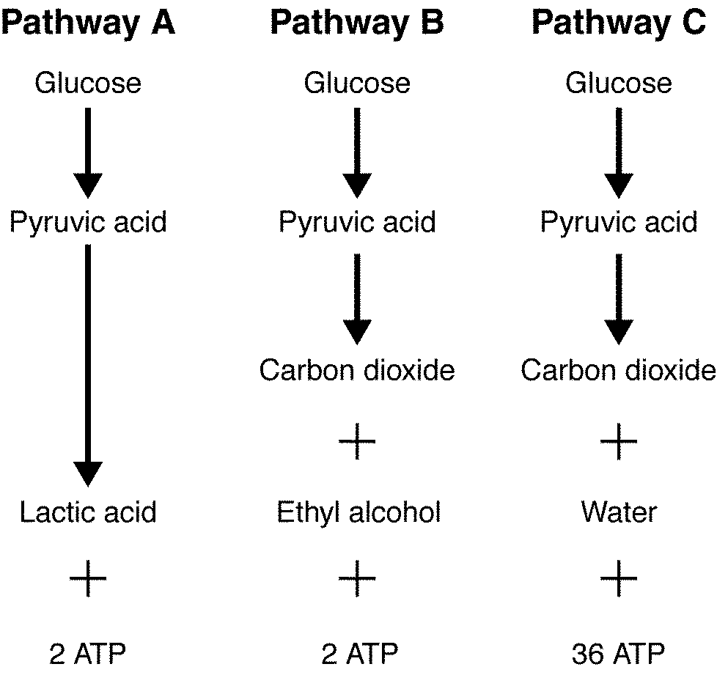  Pathway B demonstrates what process?  - lactic acid fermentation  - alcoholic fermentation  - photosynthesis  - chemiosmosis | One cause of muscle soreness is  - alcoholic fermentation  - lactic acid fermentation  - glycolysis  - the Krebs cycle
Define lactic acid fermentation: | Define glycolysis:

Warm Up #7

Organelles are used in both photosynthesis and cellular respiration.
Explain which organelles are used for which processes and explain the job of each organelle.

Warm Up #8
Why are photosynthesis and cellular respiration often considered opposites?  - Photosynthesis produces twice as many ATP molecules as cellular respiration does.  - Water is released during photosynthesis and consumed during cellular respiration.  - Photosynthesis occurs during the day, and cellular respiration occurs at night.  - Oxygen is produced during photosynthesis and used during cellular respiration. | Which of these statements best explains the process of energy conversion that takes place in the mitochondria?  - Energy is required for carbon dioxide molecules to form six-carbon sugar molecules.  - Water molecules and radiant energy are necessary for anaerobic respiration to take place.  - Oxygen molecules release energy in the form of heat during combustion reactions.  - The energy in the bonds of glucose molecules is transferred to the phosphate bonds in ATP.
Define opposites: | Define respiration:

Warm Up #9
Which statement best describes the relationship between the products of photosynthesis and the reactants in cellular respiration?  - The products of photosynthesis serve as the reactants in cellular respiration to provide chemical energy.  - The products of photosynthesis combine with the reactants in cellular respiration to remove ATP from cells.  - The products of photosynthesis inhibit the reactants in cellular respiration in the presence of light.  - The products of photosynthesis change the structure of the reactants in cellular respiration in the presence of light. | Cellular Respiration is important to most organisms because __________.  - food energy is converted into a form for cell use  - carbon dioxide is removed from the atmosphere  - oxygen is removed from the atmosphere  - it is an external stimulant
Define chloroplast: | Define reactant:

Warm Up #10
R E A C T A N T P J H T I Y C
ACID
AEROBIC
ANAEROBIC
ATP
CARBON
CELLULAR
CHLOROPLAST
DIOXIDE
GLUCOSE
GLYCOLYSIS
LACTIC
OXYGEN
PHOTOSYNTHESIS
PRODUCT
REACTANT
RESPIRATION
SUNLIGHT
WATER
O C K U F C V F H U G P C V A
I H P O I S I V O G F R I T R
G F S T X S C Y T T R O B E B
H C C U W V I A O E H D O D O
B A O A N F G S S P U U R I N
L N T Z L L T P Y G H C E X L
G E N F U Q I R N L P T A O D
R D I C A R A G T T O T N I E
A M O K A L L C H W Q C A D U
V S M T U Q N S E T W P Y O F
E S I L H A K W S Z T V S L H
O O L R U M B C I B O R E A G
N E O X Y G E N S E N A M D J
C T S A L P O R O L H C J A A

